[](https://www.google.com/url?sa=i&url=http%3A%2F%2Fysgolpenmorfa.com%2Flogo-2-2%2F&psig=AOvVaw0IC1fhXFAUrvqjEhsHjBOw&ust=1587731828247000&source=images&cd=vfe&ved=0CAIQjRxqFwoTCPjAkY3H_ugCFQAAAAAdAAAAABAe)

**Ysgol Penmorfa**

**Newsletter**

10th March 2023 (No. 23)

Year 4 had a great day out at Greenfield Valley, taking part in a World War 2 workshop and having time to explore the park too. A valuable learning experience indeed.

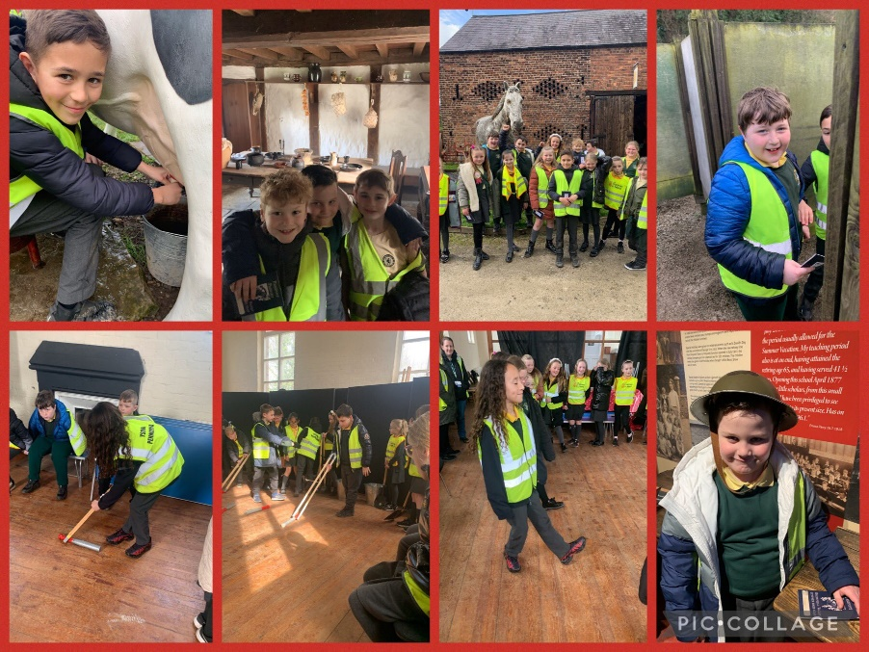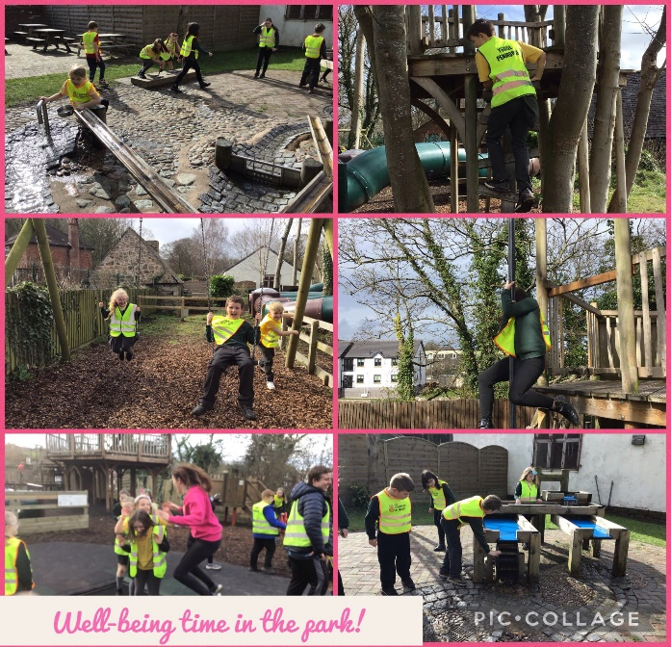

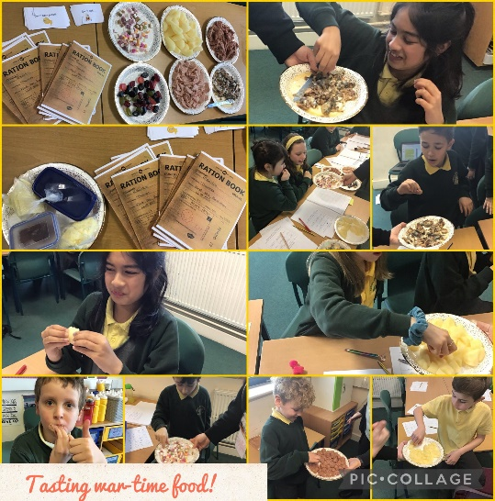

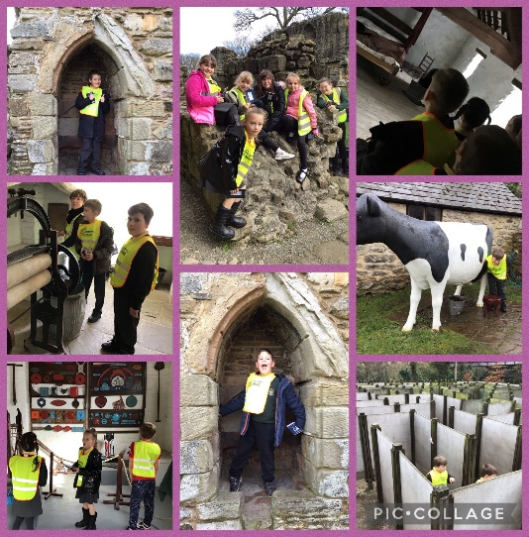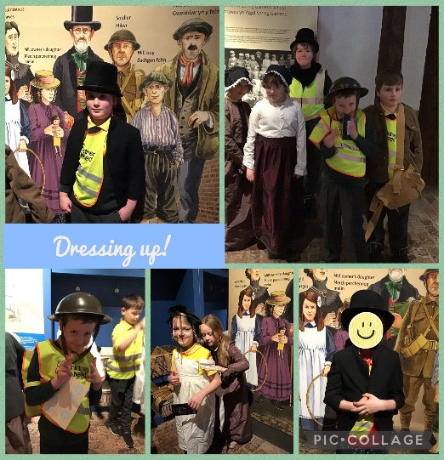



Happy Birthday

Miley-Grace M - 19th March

Dexter J - 19th March

Cole E - 20th March

Reece M - 20th March

Codey C - 21st March

Harper M – 23rd March

Penblwydd Hapus

Lyla H in 2G

got ‘Rainbow

of the Month’

and is very

proud to have

‘Sunshine’ the

miniature

rainbow for

the month.

Well done

Lyla!

Da iawn ti!

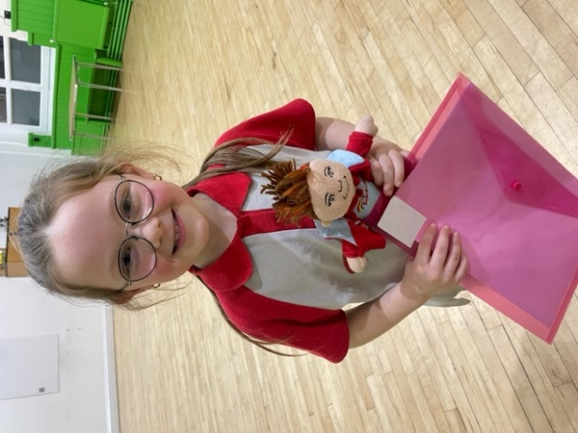

Blwyddyn 4 have been learning how to code a MicroBit for a variety of purposes. They created a step-counter and a buzz wire game! We are learning to be enterprising, creative contributors of Wales and the world.

Important dates for your diary

**Diversity week at Prestatyn High (Year 1 – Year 6 will be going there for various activities this week)**

Monday 27th March

Y1 & Y2 Forest School/Life Skills

Tuesday 28th March

Y3 & Y5 Forest School/Life Skills/Builders Yard

Coffee Morning 9.15am

PC Manus to Y5 & Y6

2R Class Service 2.30pm All welcome

Wednesday 29th March

Reception Forest School/Life Skills

Solihull Workshop AM

Y5 to Kingswood

PC Manus to Y3 & Y4

Church Easter Service

Thursday 30th March

Y6 & Y4 Forest School/Life Skills/Builders Yard

Y3 Swimming

2G Class Service 9.15am All welcome

Friday 31st March

Language & Play 9.30 – 11.30am

Y4 Class Service 9.15am All welcome

Y5 back from Kingswood

Break up for Easter Holidays

Monday 17th April

**INSET DAY**

Tuesday 18th April

Children return to school

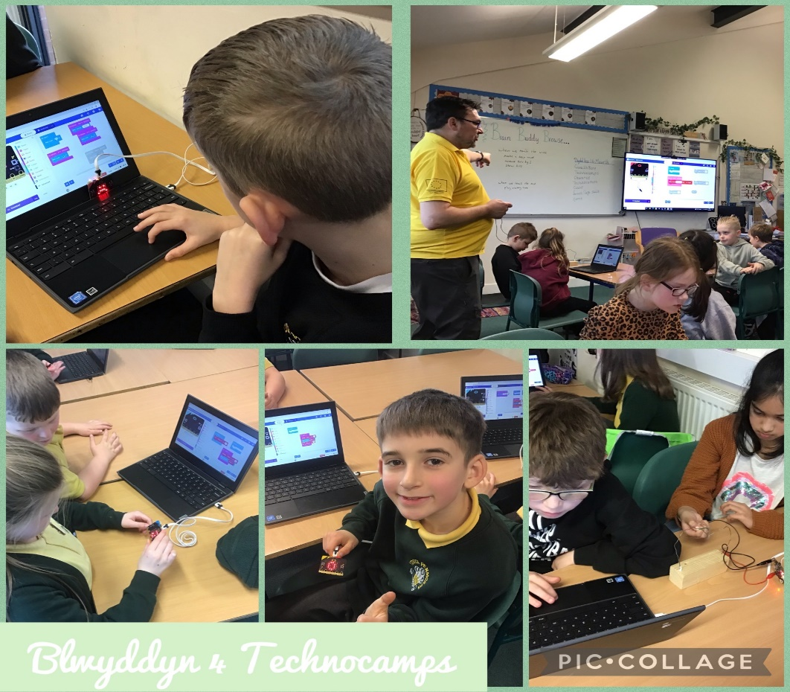

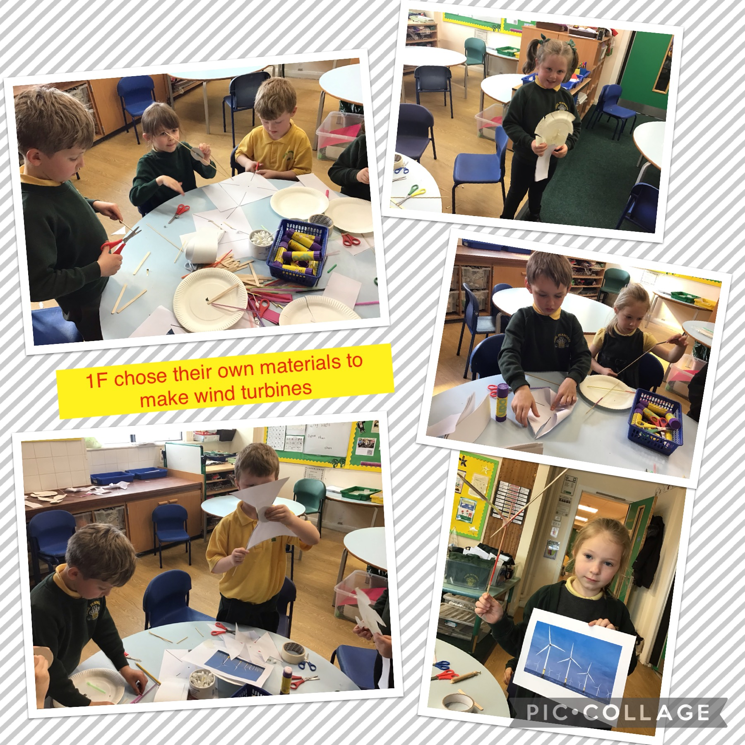

We are going the celebrate the King’s Coronation with a picnic on the field on the afternoon of Friday 5th May. The last picnic we had for the Queen was fantastic and the feedback from parents was great. Further details will follow but please ‘save the date’.

**Making the Most of Everyone**